USER GUIDE
PORTAL REGISTRATION:
Open the Workplace+ URL - https://workplaceplus.mitie.com/login.aspx in any bowser (Google Chrome, Microsoft Edge, Internet Explorer, etc).
The below page will be loaded.
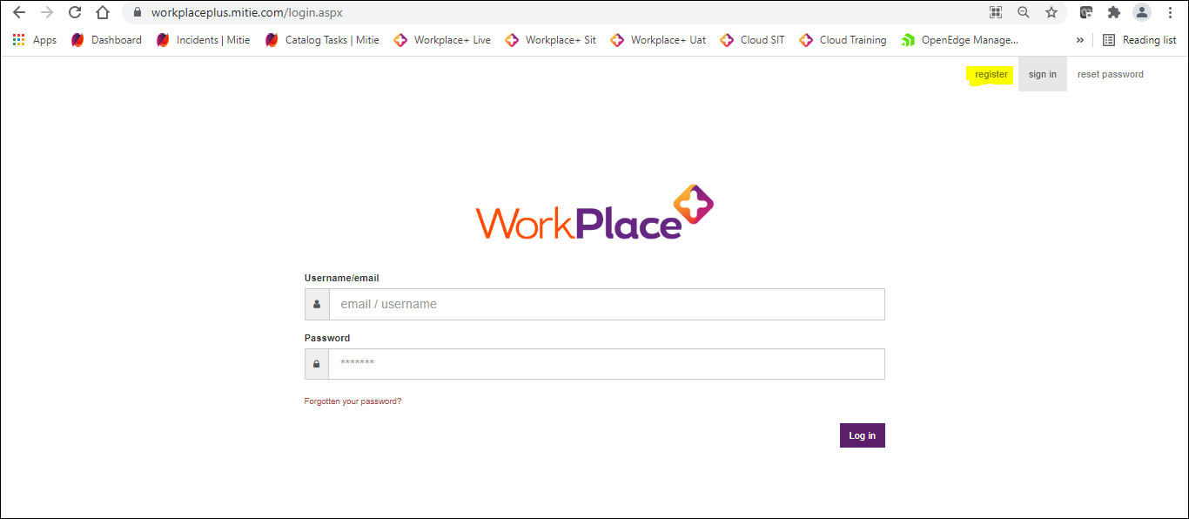
Now click on Register as highlighted in the above screenshot and enter the below details:
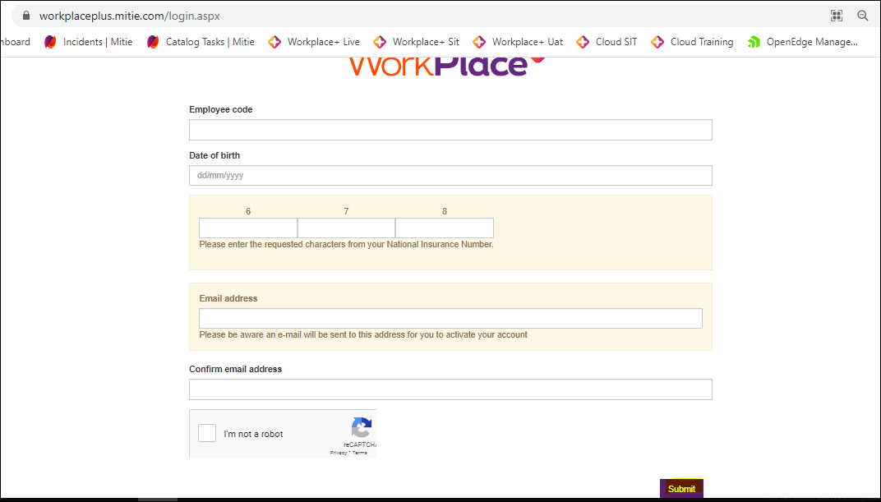
Employee Number: WP+ employee number (please don’t use Payroll number, if you are not aware of your WP+ employee number please contact your line manager)
Date of Birth: Enter DOB (format: dd/mm/yyyy)
NI Number: Enter NI Number (Enter the requested characters from your National Insurance Number)
Email address and confirm Email address: Enter email address that you want to register on WP+.
And click on I am not a robot checkbox and submit it.
It will redirect to the below page then please set the password for your account.
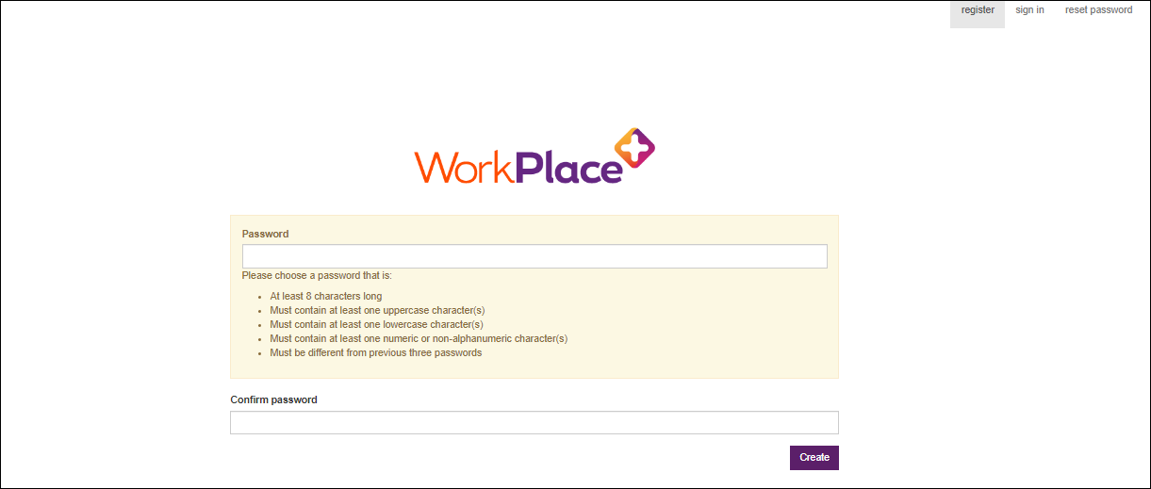
Enter the password and confirm password as per the instructions given and click on create.
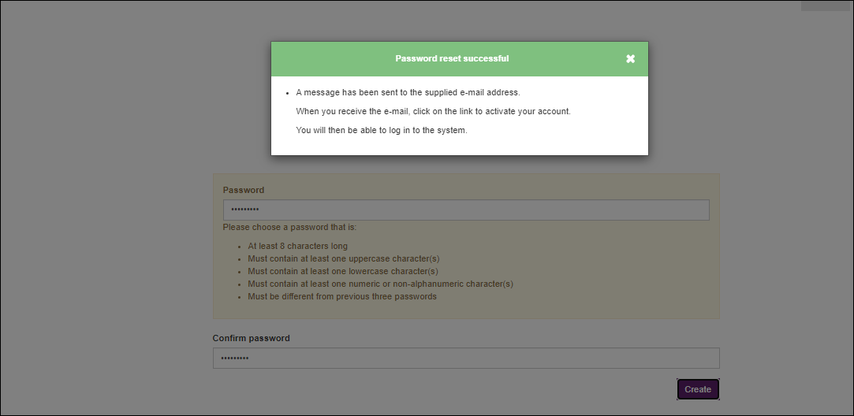
Now an email will be sent to your registered email address with activation link.

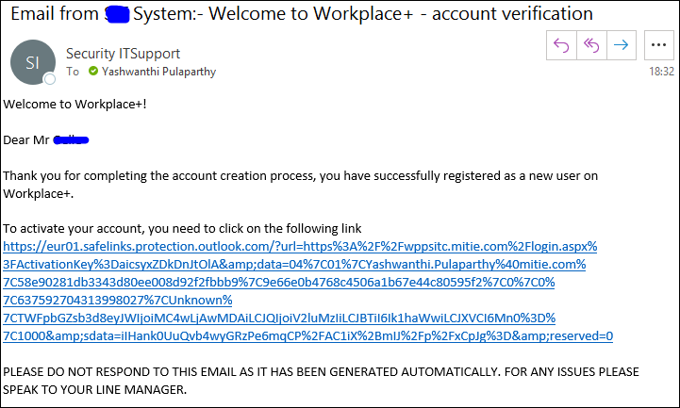
Please click on the link and activate your account (Link will expire in 7 days). Once it is activated, you will then be able to login into the WP+ system.
From next time use the same WP+ URL (https://workplaceplus.mitie.com/login.aspx) to sign in into WP+.
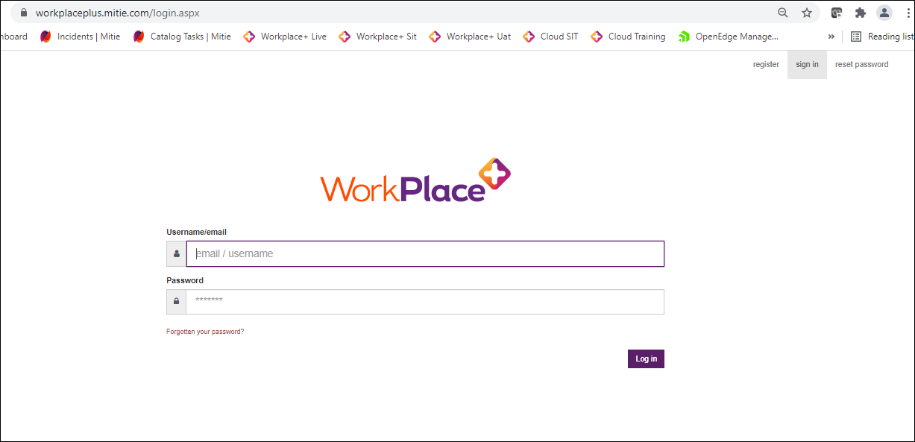

PORTAL PASSWORD RESET:
Open the Workplace+ URL - https://workplaceplus.mitie.com/login.aspx in any bowser (Google Chrome, Microsoft Edge, Internet Explorer, etc) and click on password reset button at top right corner.
Now enter the Username (Give Email id that you have registered on WP+) and click on I am not a robot checkbox and submit it.
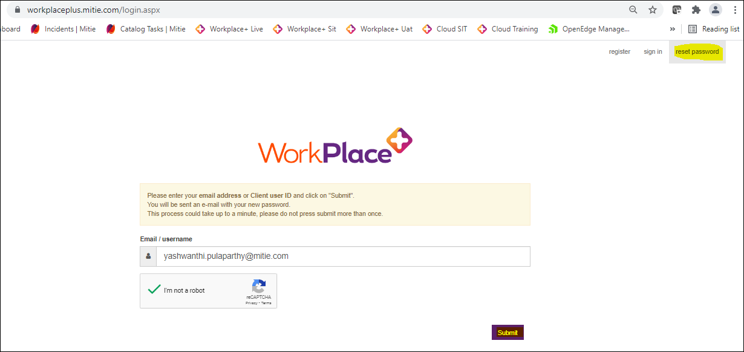
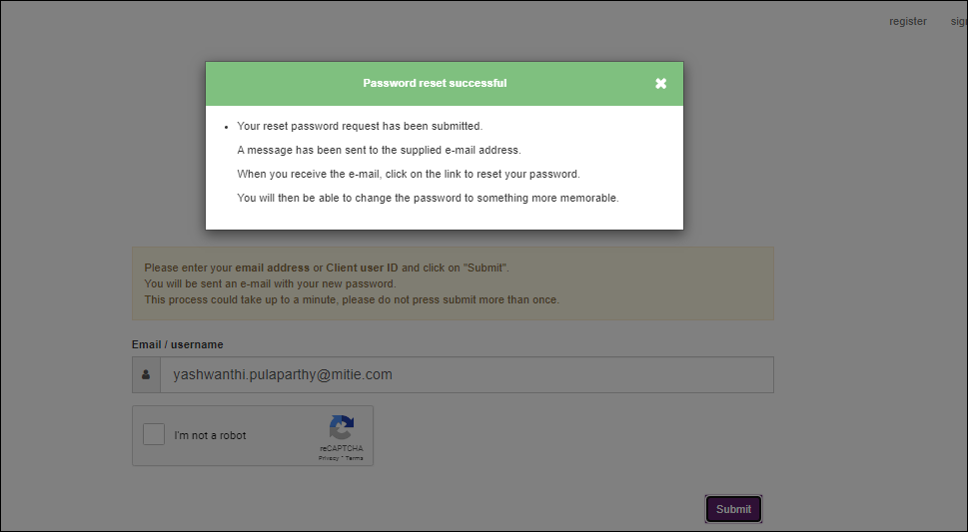
Then an email will be sent to your registered email address with password reset link. Please click on that link and set your password as per the instructions given and click on submit.
